Multimedia Story

AJ Truscello

Music is a form of media that people consume almost every day. It is used as a form of expression for many and is used to connect with people around the world. The University of South Florida has many clubs on campus used to connect students with one another. One of these clubs is dedicated to bringing people together in USF through the power of music and shows the importance of having clubs for students in USF: the Music Appreciation Club.

The Music Appreciation Club meets every Friday at 5:30. Members of the club play their favorite music that they’ve been listening to, while socializing and building new relationships with other students on campus. Before their first meeting on January 17th, I was able to interview the club’s President, Allan Gonzalez H’P.

Full, unedited interview with Music Appreciation Club (MAC) President Allan Gonzalez H’P.

Photo of MSC 3712, location of the club’s first meeting.

Q: Why do you believe it’s important to have clubs this at USF, like the Music Appreciation Club and other clubs around campus?

A: *“I feel like it’s just very important to have clubs where people can just, like find other students with similar interests, so it’s easier to make friends, because it’s like very intimidating to start college…”*

*“…I was a transfer student here at USF and I was here like all over knowing no one, and like MAC was one of the first few clubs I first joined when I first transferred here, and I ended up making my main friend group out of there. So, I just think it’s important to have, like a bunch of recreational, fun clubs around campus where students can engage with each other, hang out with each other, make friends, talk about cool stuff, like music, movies and stuff like that”.*

Q: Do you think the club has made an impact on your life and the club members?

A: *“I would say, like, it’s definitely affected my personal life in a sense where, like, I literally met, like two of my best friends in this club and I definitely grew to enjoy and appreciate different types of music”.*

Q: Where do you see the club after you’ve graduated USF, and will it continue to be what you built it to today?

A: *“I think the club will be just fine. It’ll continue, I’m pretty sure in the same way it is right now. One of our recently appointed Vice Presidents is actually a freshman here and she’s probably going to end up becoming the future President of MAC and basically continuing what we all started here…”*

*“Yeah, music is always gonna be here forever and keep connecting people together, so as long as there’s music, the club will probably still exist”.*

*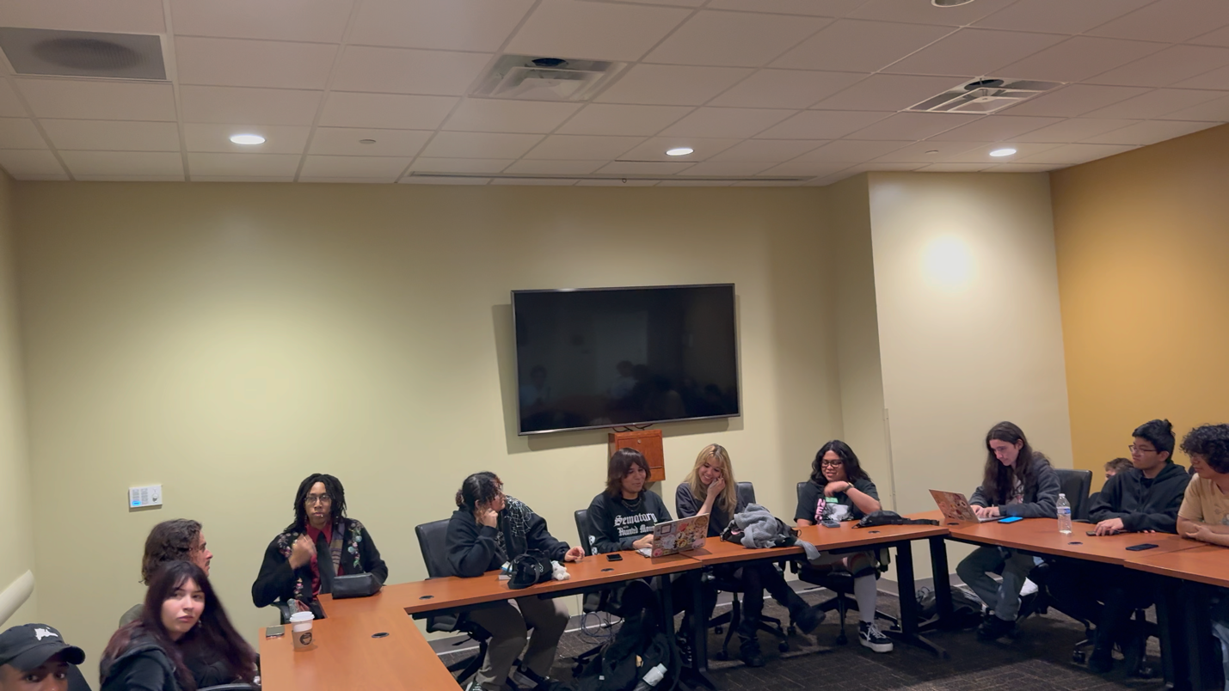*

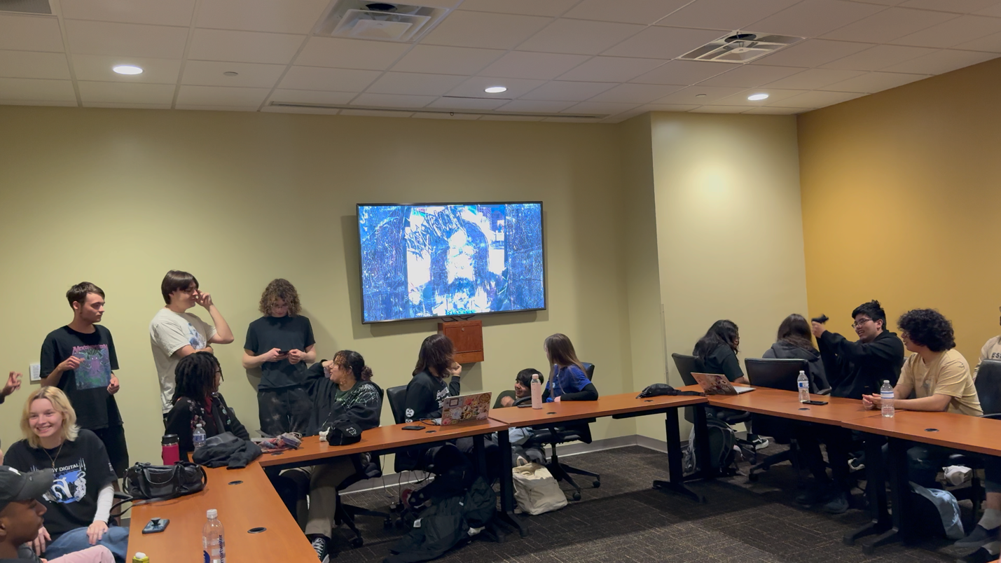

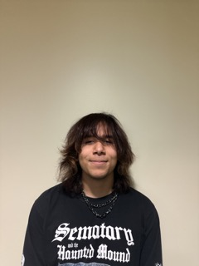

Photo of Allan Gonzalez H’P, President of the Music Appreciation Club.

Contact Information: [allang60@usf.edu](mailto:allang60@usf.edu)